

ENEL2SEH1 – Project 1 2026
SMART PROPERTY MANAGEMENT SYSTEM
Phase 1, 2 & 3 Submission
Samukelo Jili 225004064
Siyavuya Mkhize 225110145
Sphumelele Ngidi 225006095
Lihle Nkomo 225163975
Wandile Zuke 225024142

Table Of Contents

1. Introduction 4
1.1 System Overview 4

2. Requirements Analysis 4
2.1 Functional Requirements 4
2.1.1 Customer (Tenant) Requirements 4
2.1.2 Property Owner (Landlord) Requirements 4
2.1.3 Administrator Requirements 5
2.1.4 Data Handling Requirements 5
2.2 Non-Functional Requirements 5

3. System Design 7
3.1 Architectural Design 7
3.2 Use-Case Diagram 8
3.3 Domain Model (Class Diagram) 8
3.4 Database Design 9
3.4.1 Entity-Relationship Diagram 9
3.4.2 Relational Schema (Normalised to 3NF) 9
3.5 Interaction Design (Sequence Diagrams) 10
3.6 Behavioural Design (Activity Diagrams) 13
3.7 State Machine Design 14
3.8 Deployment View 18
3.9 User Interface Wireframes 19

4. Implementation 20
4.1 Technology Stack 20
4.2 Project Structure 20
4.3 Core Algorithms 21
4.4 Integration Sequence 22

5. Module Design 24
5.1 Introduction 24
5.2 Module Decomposition Map 24
5.3 Module Interface Contract 24
5.4 Module 1 — Database Foundation 25
5.5 Module 2 — Authentication & Authorisation 26
5.6 Module 3 — User Management 28
5.7 Module 4 — Property Management 30
5.8 Module 5 — Ownership Management 32
5.9 Module 6 — Lease Management 34
5.10 Module 7 — Payment Management 36
5.11 Module 8 — Maintenance Management 38
5.12 Module 9 — Notification & Preference System 40
5.13 Module 10 — Dashboard, Reporting & Email Dispatch 42
5.14 Cross-Module Interactions 44
5.15 Module Dependency Graph 44
5.16 Requirements Traceability Matrix 44

1.Introduction
1.1 System Overview
The Smart Property & Accommodation Management System is a comprehensive desktop platform designed to streamline property operations in South Africa. It provides a unified interface for renters, landlords, and administrators, offering tools for property discovery, lease management, secure transaction tracking, and listing administration. The system is implemented as a Python/PySide6 desktop client backed by a relational SQLite database, providing a localized, self-contained foundation for the modern property market.

2.Requirements Analysis
2.1 Functional Requirements
Functional requirements describe the specific services, features, and capabilities the system must provide.
2.1.1 Customer (Tenant) Requirements
The system must:
- Allow customers to register, log in, and provide their South African ID or passport number for storage and manual verification by an administrator.
- Allow customers to search for available properties, view details, photographs, pricing, and full address information.
- Allow customers to request property viewings and receive in-app confirmation notifications.
- Allow customers to reserve accommodation and generate lease agreements digitally within the system.
- Allow customers to record and track rent and deposit payments against their active lease.
- Allow customers to view their payment history, active leases, and leave reviews on properties they have occupied.
2.1.2 Property Owner (Landlord) Requirements
The system must:
- Allow owners to create and manage property listings, including address, type, build details, and pricing.
- Allow owners to upload and manage property photographs and toggle listing availability.
- Allow owners to review a prospective tenant's profile and ID information before approving a lease request.
- Allow owners to track monthly revenue streams and manage recurring lease billing for long-term tenants.
- Allow owners to receive maintenance tickets from tenants, update the status of repairs, and notify tenants automatically through in-app notifications.
2.1.3 Administrator Requirements
The system must:
- Allow administrators to verify, approve, or reject new property listings to maintain platform quality.
- Allow administrators to manage customer and owner accounts, including dispute resolution and account suspension.
- Allow administrators to generate financial, user-activity, and platform growth reports.
- Allow administrators to monitor system activity, user reports, and overall platform health.
2.1.4 Data Handling Requirements
The system must:
- Generate lease agreements as PDF documents that can be printed, signed, and uploaded back to the system.
- Capture explicit user consent for data processing during registration and prompt users before any optional data-sharing action.
- Store all user data locally in the application database, accessible only to authorised roles.

2.2 Non-Functional Requirements
Non-functional requirements dictate system performance, security, and operational qualities.
- Security & Privacy: The platform must protect personal data, securely store passwords using modern hashing algorithms (bcrypt), and restrict sensitive features to authorised personnel based on role.
- Usability & Accessibility: The interface must be intuitive, consistent across screens, and cater to individuals of varying technical literacy through clear navigation and feedback.
- Performance: The architecture must process searches and database queries rapidly, ensuring property images and listing data load without perceptible delay on typical desktop hardware.
- Reliability: The application must always maintain data integrity, guarantee accurate availability data to prevent double-bookings, and ensure transaction data is never lost during unexpected shutdowns.
- Scalability: The architecture must support growth in the number of users, properties, and records without requiring redesign, and provide a clear path for future addition of third-party integrations.

Phase 2 — System Design & Module Design

3. System Design
3.1 Architectural Design
The system adopts a four-tier layered architecture consistent with established software engineering practice (presentation, application, domain, persistence). Each tier depends only on the tier immediately below, satisfying the Dependency Inversion Principle and enabling independent testing and replacement.
Tier | Responsibility | Technology
Presentation | Render UI, capture user events | PySide6 (Qt for Python)
Application | Coordinate use-cases, validate input, enforce permissions | Python controllers
Domain | Business rules, entity behaviour, cross-entity operations | Python services
Persistence | Store and retrieve entities | SQLAlchemy ORM + SQLite
Cross-cutting | Scheduled tasks, email dispatch | APScheduler + smtplib

Component Diagram
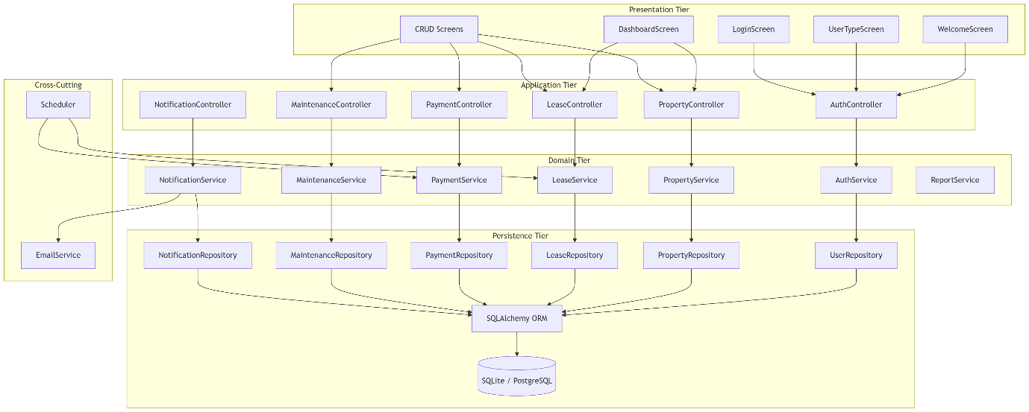

3.2 Use-Case Diagram
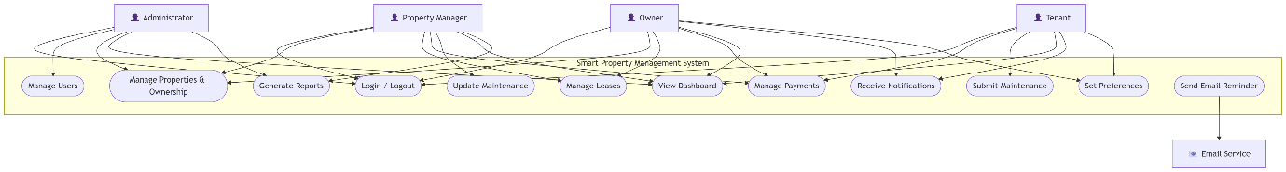

3.3 Domain Model (Class Diagram)
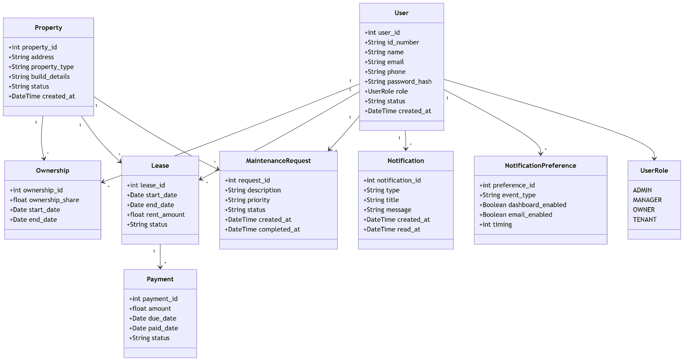

3.4 Database Design
3.4.1 Entity-Relationship Diagram
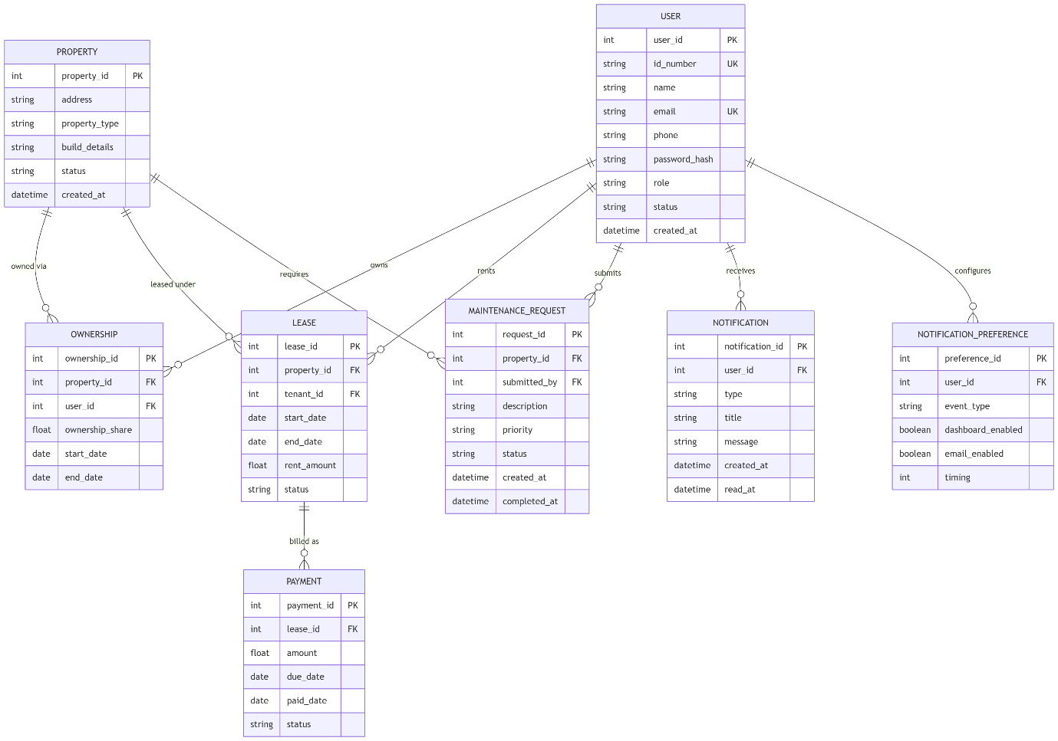

3.4.2 Relational Schema (Normalised to 3NF)
USERS (<u>user_id</u>, id_number, name, email, phone, password_hash, role, status, created_at)
PROPERTIES (<u>property_id</u>, address, property_type, build_details, status, created_at)
OWNERSHIPS (<u>ownership_id</u>, property_id†, user_id†, ownership_share, start_date, end_date)
LEASES (<u>lease_id</u>, property_id†, tenant_id†, start_date, end_date, rent_amount, status)
PAYMENTS (<u>payment_id</u>, lease_id†, amount, due_date, paid_date, status)
MAINTENANCE_REQUESTS (<u>request_id</u>, property_id†, submitted_by†, description, priority, status, created_at, completed_at)
NOTIFICATIONS (<u>notification_id</u>, user_id†, type, title, message, created_at, read_at)
NOTIFICATION_PREFERENCES (<u>preference_id</u>, user_id†, event_type, dashboard_enabled, email_enabled, timing)
*Unique. †Foreign key referencing the parent table.

Normalisation justification.
- 1NF: All attributes are atomic; no repeating groups. Co-ownership is modelled as multiple OWNERSHIP rows rather than a repeating attribute on PROPERTY.
- 2NF: Every non-key attribute depends on the whole primary key. In OWNERSHIPS the composite business key (property_id, user_id, start_date) has no partial dependencies.
- 3NF: No transitive dependencies. For example, property_address is not stored on LEASES — it is retrievable via property_id, avoiding update anomalies.

3.5 Interaction Design (Sequence Diagrams)
3.5.1 User Login
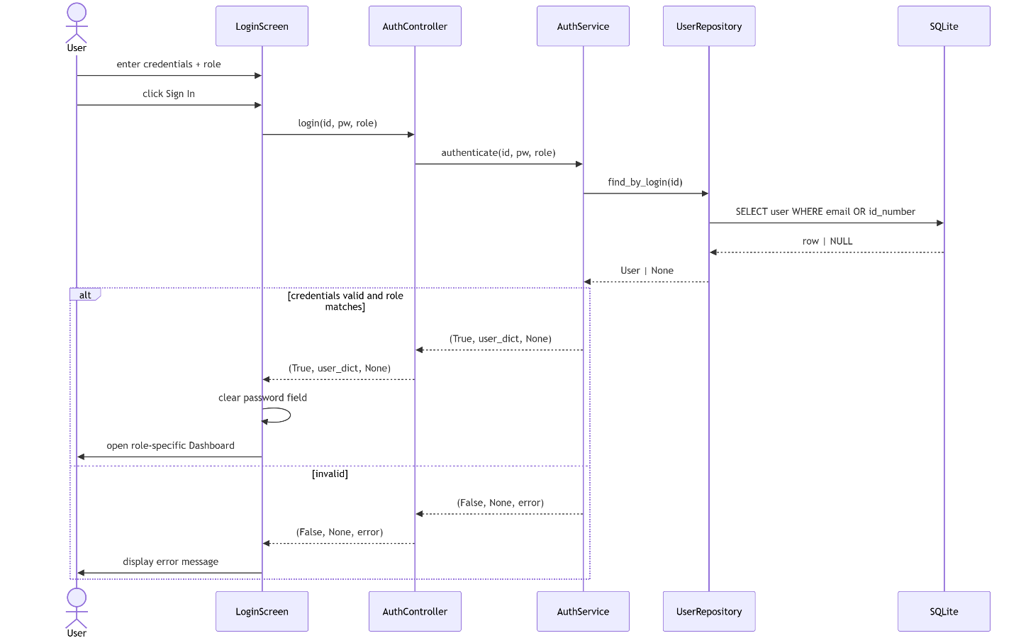

3.5.2 Add Property
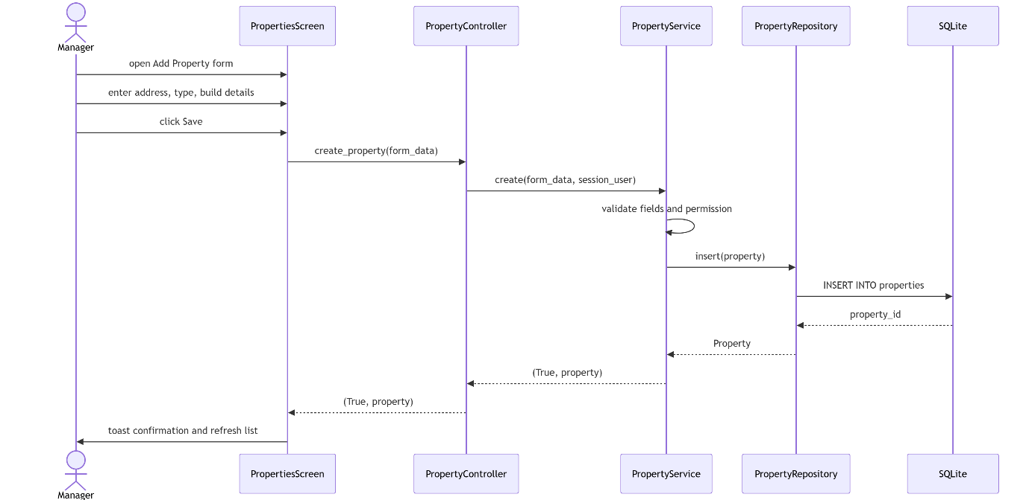

3.5.3 Automated Reminder Dispatch
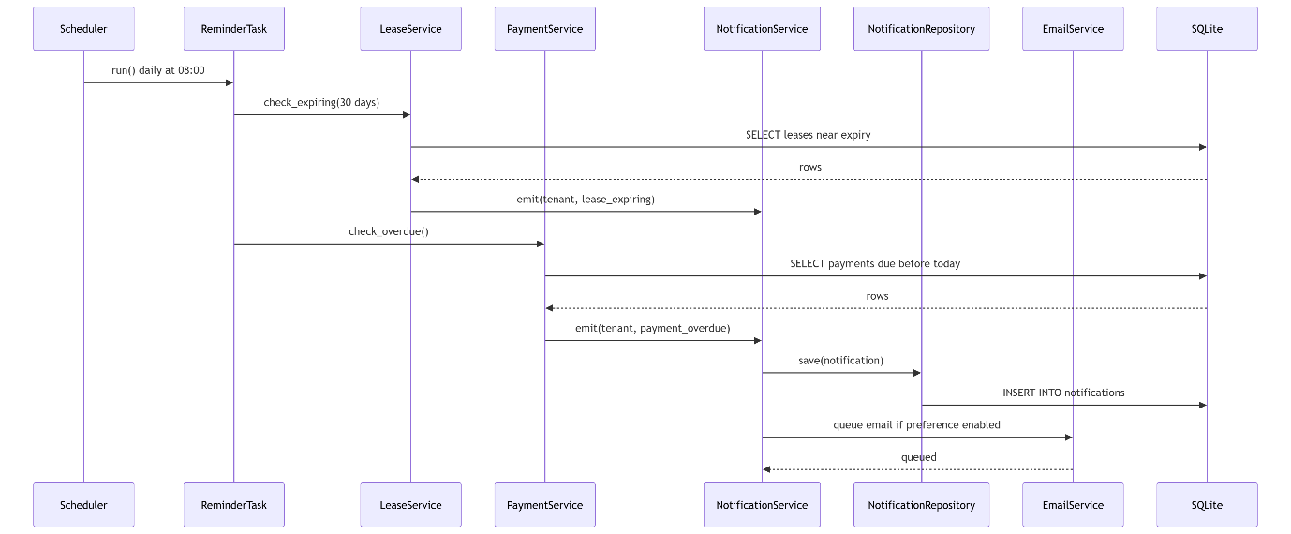

3.5.4 Maintenance Request Lifecycle
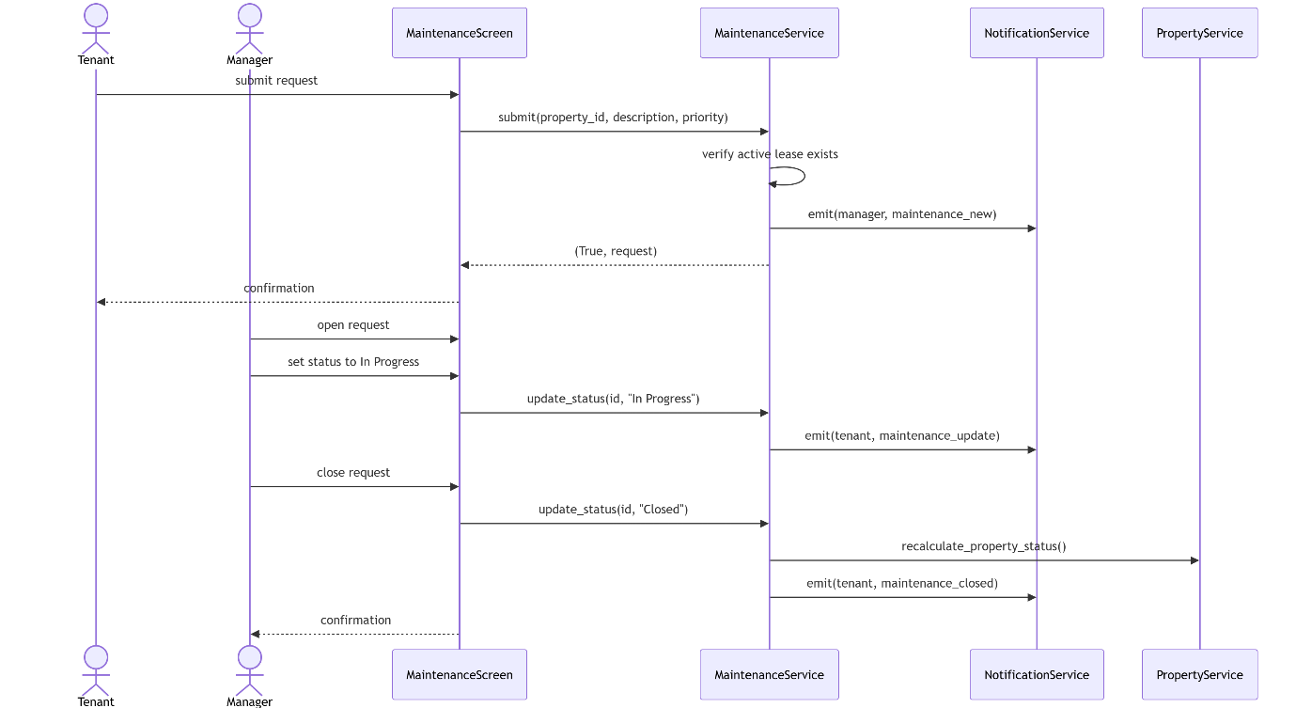

3.6 Behavioural Design (Activity Diagrams)
3.6.1 Login Activity
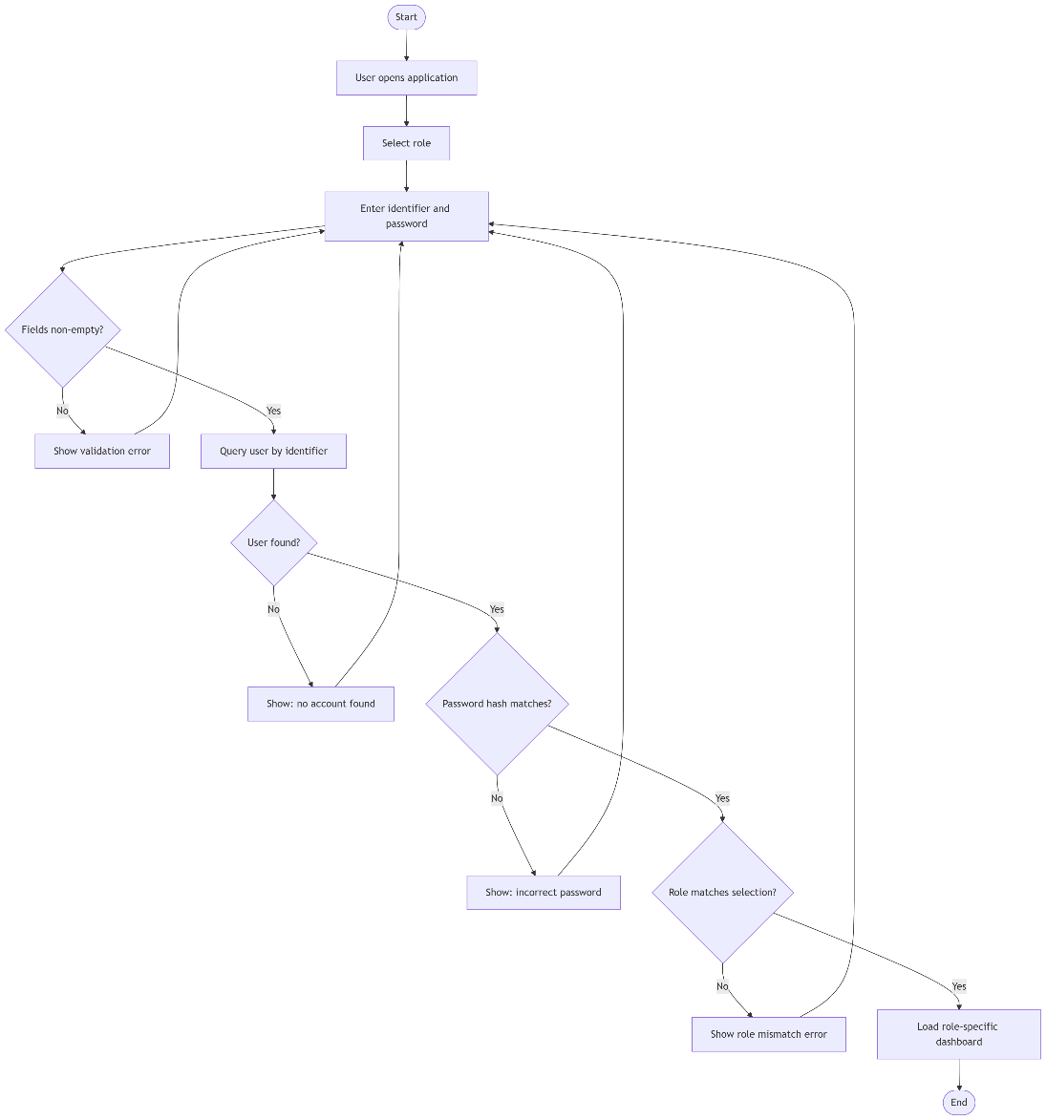

3.6.2 Property Registration Activity
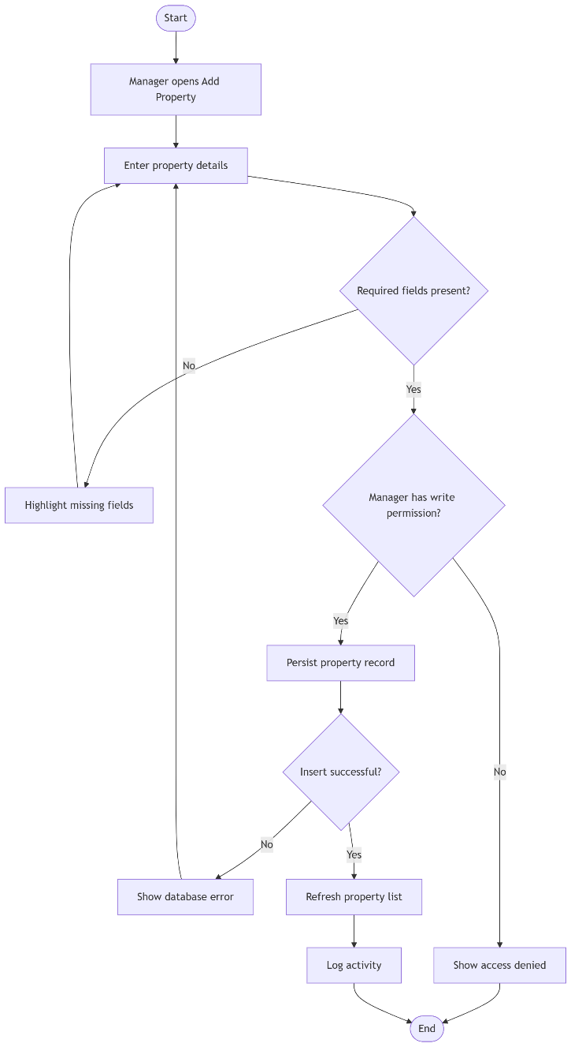

3.7 State Machine Design
3.7.1 Property Lifecycle
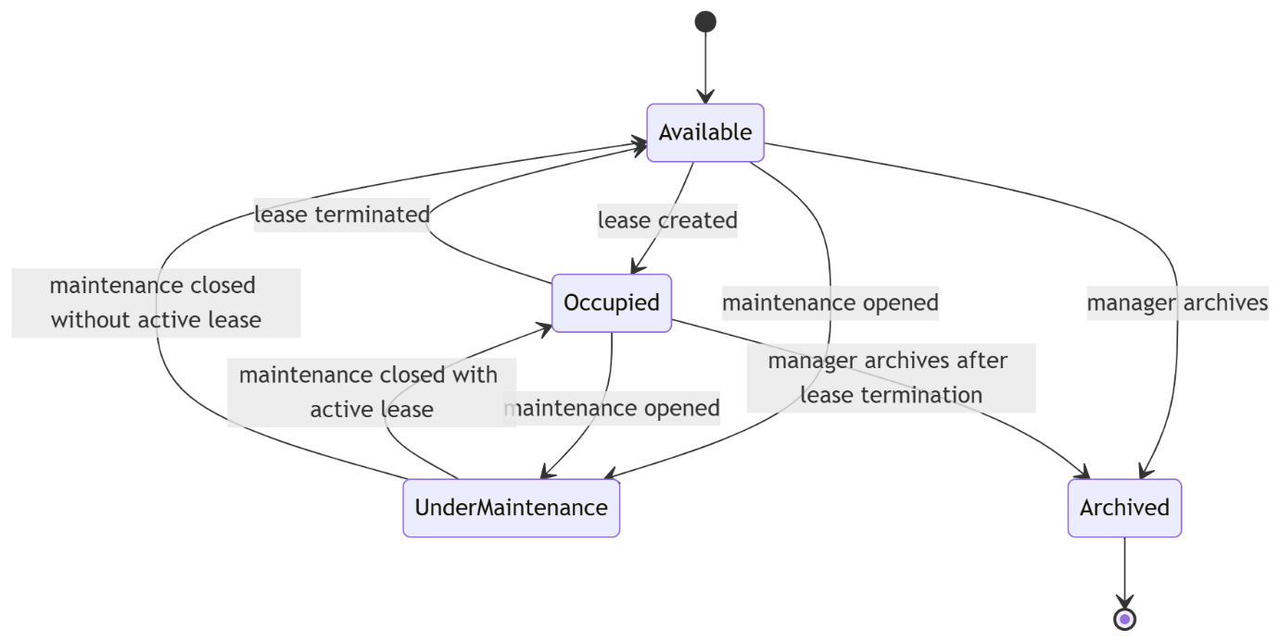
3.7.2 Lease Lifecycle
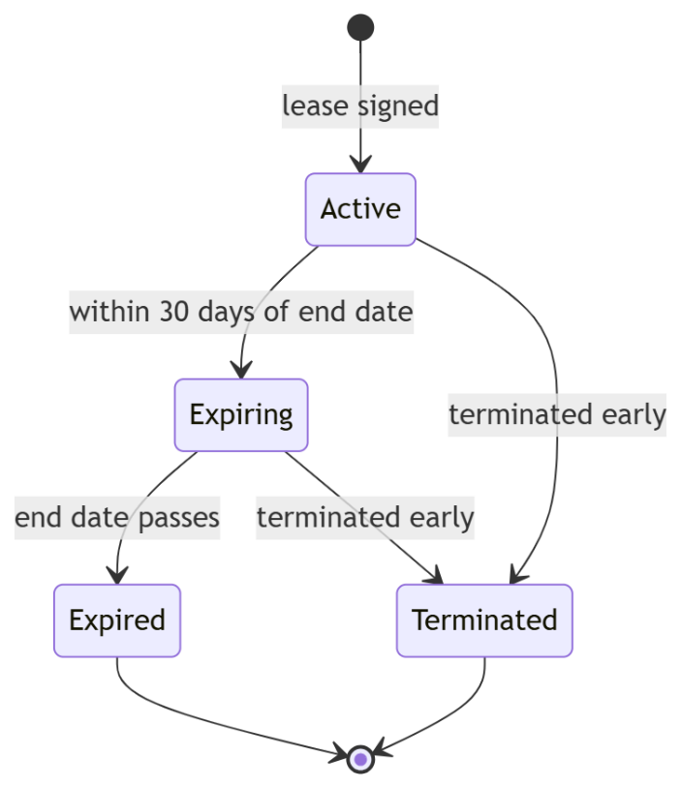

3.7.3 Payment Lifecycle
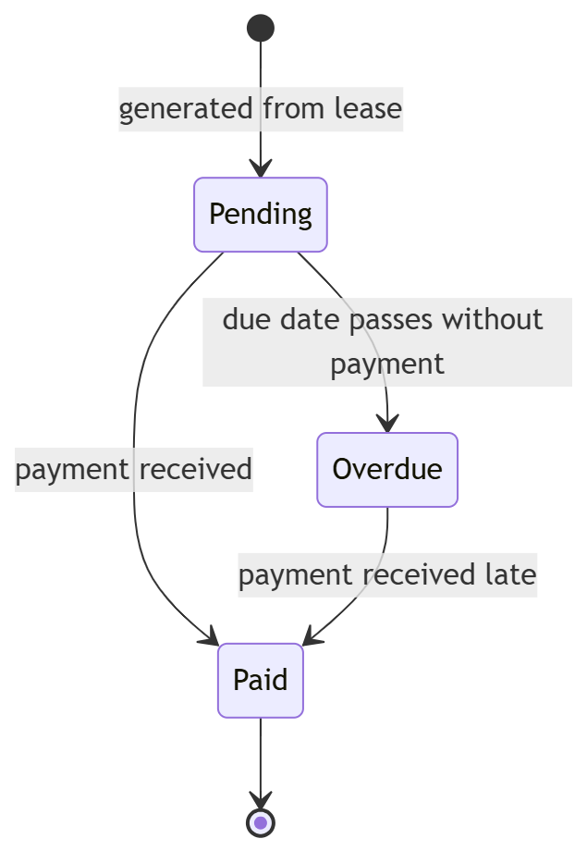

3.7.4 Maintenance Request Lifecycle
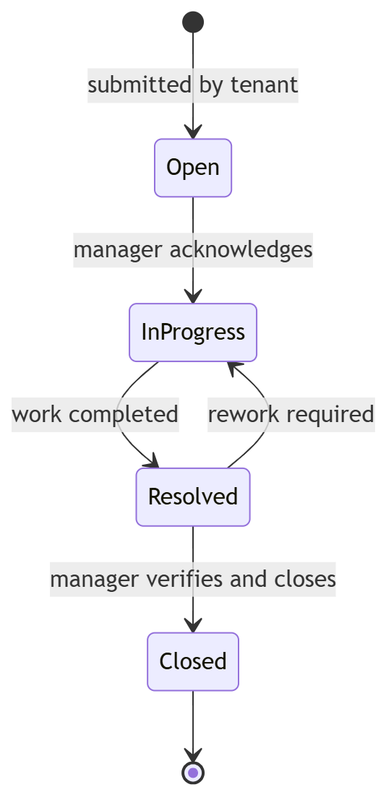

3.8 Deployment View
The system is delivered as a desktop application. Each user runs a local instance of the Python/PySide6 client. Data persistence is provided by an embedded SQLite database for development and demonstration purposes and a networked PostgreSQL instance for production configuration. Outbound email is dispatched via an SMTP relay.
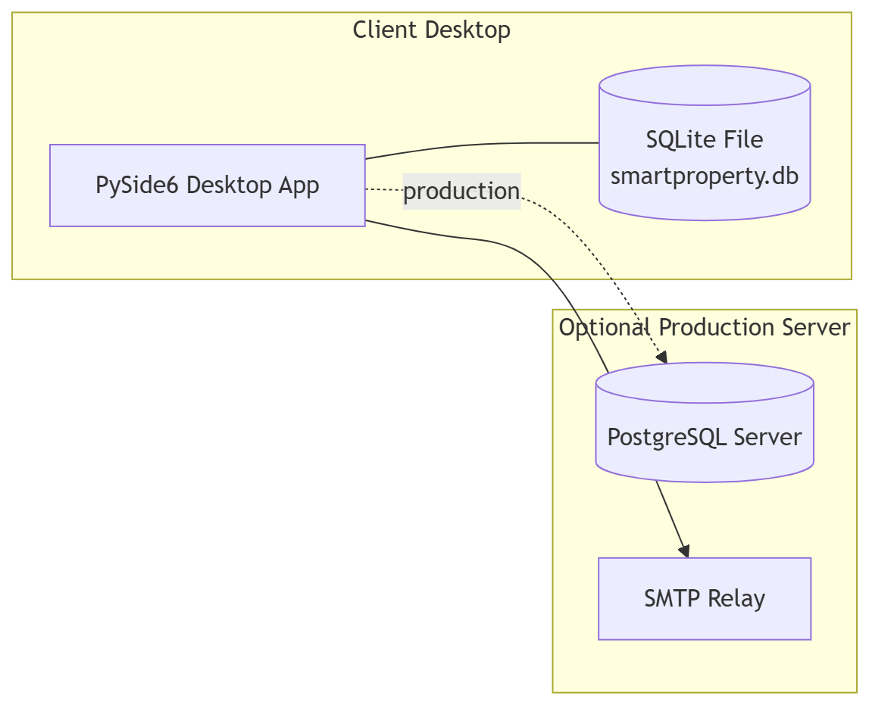
Deployment rationale.
- SQLite eliminates server dependency for the academic demonstration environment.
- SQLAlchemy's connection URL is the single point of change between the two configurations, so no application code is modified during the transition.
- Email is optional; the notification subsystem functions fully without it, satisfying the "graceful degradation" non-functional requirement.

3.9 User Interface Wireframes
Wireframes are provided as image files, rendered from the specifications below. Each screen is designed to be minimal, role-appropriate, and consistent with the layered architecture.
Screen | Purpose | Key elements
Welcome | Entry point | Product logo, tagline, Get Started call-to-action
User Type | Role selection | Four large role cards with icons
Login | Credential capture | Identifier, password with show/hide, error panel, role indicator
Dashboard | Role-aware overview | Statistics cards, quick action tiles, recent activity, notification bell
Properties | Property CRUD | Filterable table, Add/Edit modal, archive action
Leases | Lease management | Timeline view, expiry badge, terminate action
Payments | Payment tracking | Lease-grouped table, overdue highlights, mark-as-paid
Maintenance | Request handling | Kanban-style columns (Open / In Progress / Resolved / Closed)
Notifications | Notification centre | Unread-first list, mark-as-read, preference link
Reports | Report generation | Filter panel, preview pane, PDF export

4. Implementation

4.1 Technology Stack
Layer | Technology | Justification
Language | Python 3.14 | Rapid development, rich ecosystem, suitability for both UI and business logic
GUI | PySide6 (Qt 6) | Mature, cross-platform, native look-and-feel, LGPL
ORM | SQLAlchemy 2.0 | Declarative mapping, dialect independence, supports both SQLite and PostgreSQL
Database (dev) | SQLite | Zero-config, file-based, ideal for demonstration
Database (prod) | PostgreSQL | ACID guarantees, concurrent access, production-grade
Password hashing | bcrypt | Adaptive cost factor, resistant to rainbow tables
Charts (planned) | matplotlib | Embedded in Qt via FigureCanvasQTAgg
Reports (planned) | reportlab | Programmatic PDF generation
Scheduler (planned) | APScheduler | In-process cron-style task scheduling
Version control | Git + GitHub | Standard industry practice, off-machine backup

4.2 Project Structure
text
SmartPropertyManagementSystem/
├── main.py
├── requirements.txt
├── ui/ # Presentation tier
├── Controllers/ # Application tier
├── Services/ # Domain tier
├── Repositories/ # Persistence tier (data access)
├── Models/ # SQLAlchemy entity definitions
├── Database/ # Engine, session, schema, seeds
├── Diagrams/ # UML and wireframe assets
├── Documentation/ # Chapter documents and module design
├── Tests/ # Unit and integration tests
└── Assets/ # Icons, images, stylesheets

4.3 Core Algorithms
A1 — Credential Verification
text
procedure AUTHENTICATE(identifier, password, expected_role):
if identifier is empty or password is empty:
return FAILURE("Missing credentials")
user ← UserRepository.find_by_login(identifier)
if user is null:
return FAILURE("No account found")
if not bcrypt.verify(password, user.password_hash):
return FAILURE("Incorrect password")
if expected_role is set and user.role ≠ expected_role:
return FAILURE("Role mismatch")
return SUCCESS(user)
A2 — Overdue Payment Detection (invoked daily and on-read)
text
procedure CHECK_OVERDUE():
today ← current_date()
for each payment in PaymentRepository.find(status="Pending"):
if payment.due_date < today:
payment.status ← "Overdue"
PaymentRepository.update(payment)
NotificationService.emit(
user = payment.lease.tenant,
type = "payment_overdue",
message = format("Payment %d was due on %s",
payment.payment_id, payment.due_date)
)
A3 — Lease Expiry Detection
text
procedure CHECK_EXPIRING(threshold_days):
today ← current_date()
horizon ← today + threshold_days
for each lease in LeaseRepository.find(
status="Active", end_date between [today, horizon]):
NotificationService.emit(
user = lease.tenant,
type = "lease_expiring",
message = format("Lease %d expires on %s",
lease.lease_id, lease.end_date)
)
A4 — Ownership Share Validation
text
procedure ADD_OWNERSHIP(property_id, user_id, share, start, end):
if user.role ≠ OWNER:
return FAILURE("Only owners can be assigned ownership")
if end is set and start ≥ end:
return FAILURE("Invalid date range")
active_total ← OwnershipRepository.sum_active_shares(property_id)
if active_total + share > 1.0:
return FAILURE("Shares exceed 100%")
OwnershipRepository.insert(property_id, user_id, share, start, end)
return SUCCESS
A5 — Property Status Recalculation
text
procedure RECALCULATE_PROPERTY_STATUS(property_id):
if LeaseRepository.has_active_lease(property_id):
status ← "Occupied"
else if MaintenanceRepository.has_open_request(property_id):
status ← "Under Maintenance"
else:
status ← "Available"
PropertyRepository.set_status(property_id, status)

4.4 Integration Sequence
Implementation proceeds bottom-up to keep each tier testable in isolation:
- Persistence tier — models, schema, connection, seed data.
- Domain tier — services with unit tests for A1–A5.
- Application tier — controllers, delegating only.
- Presentation tier — screens, wired screen-by-screen.
- Cross-cutting — scheduler, notification dispatch, email.
- Integration tests covering login, property CRUD, and automated reminders end-to-end.
- Documentation and UML refresh against the implemented system.

Phase 3 — Designing the Modules

5. Module Design
5.1 Introduction
Chapter 3 specified the system-level design: the four-tier layered architecture, the domain model, the database schema, and the interaction sequence diagrams. Phase 3 refines that design to the module level, specifying each module's purpose, public interface, dependencies, internal algorithms and error-handling behaviour to a level of detail sufficient for direct translation into code during Phase 4.
The ten modules identified during the decomposition are grouped into four architectural tiers, consistent with the layering introduced in Section 3.1:
Tier | Modules
Persistence | Module 1 — Database Foundation
Domain | Modules 2 — 10 (services)
Application | Controllers for Modules 2 — 10
Presentation | UI screens for Modules 2 — 10
Cross-cutting | Scheduler + Email (component of Module 10)

5.2 Module Decomposition Map
The following diagram expresses module dependencies. An edge A → B indicates that module A uses services exposed by module B.
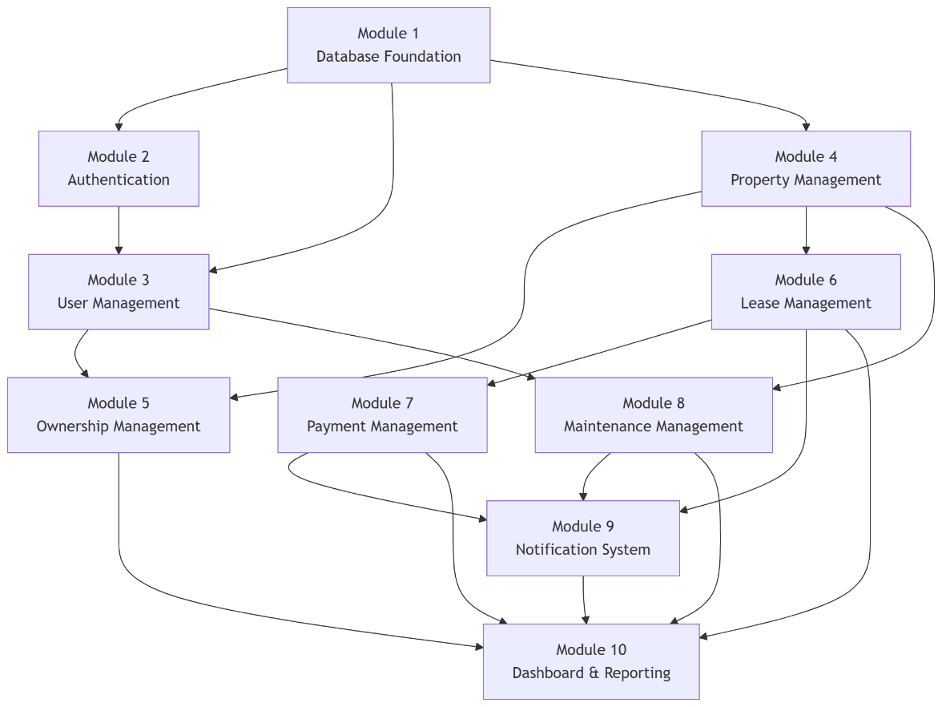

5.3 Module Interface Contract
Each module exposes a service façade — a single Python class whose public methods define its contract. Modules never call each other's repositories directly; they call services. This preserves tier isolation and enables independent unit-testing of each module with mock repositories.
The common interface convention adopted across all service modules is:
Return shape | Meaning
(True, result) | Operation succeeded; result is the created/updated entity or value
(False, error_message) | Operation rejected; message suitable for user display
list / int / entity | Simple query result; no failure case modelled
Errors are never raised across module boundaries as exceptions; they are returned as the second element of a tuple so that the UI layer can present them directly to the user without try/except clutter.

5.4 Module 1 — Database Foundation
5.4.1 Purpose
Provide a single, controlled access point to the relational store, encapsulating engine construction, session lifecycle, transaction boundaries, and schema evolution.
5.4.2 Responsibilities
- Construct the SQLAlchemy engine from a single configuration source (Database/config.py)
- Expose a scoped session factory used by repositories
- Define the declarative Base from which all entities inherit
- Create all tables on first run (idempotent)
- Seed a controlled dataset for development and demonstration
5.4.3 Public Interface
Symbol | Signature | Behaviour
get_session | () -> Session | Returns a thread-scoped SQLAlchemy session
engine | module attribute | Shared engine instance
Base | declarative base | All entity classes inherit
create_tables | () -> None | Issues CREATE TABLE for every registered model
seed_demo_data | () -> None | Inserts admin, owner, tenant, two properties, one lease, one payment, one maintenance request; no-op if any user exists
5.4.4 Dependencies
None — this is the bottom of the stack.
5.4.5 Class Diagram
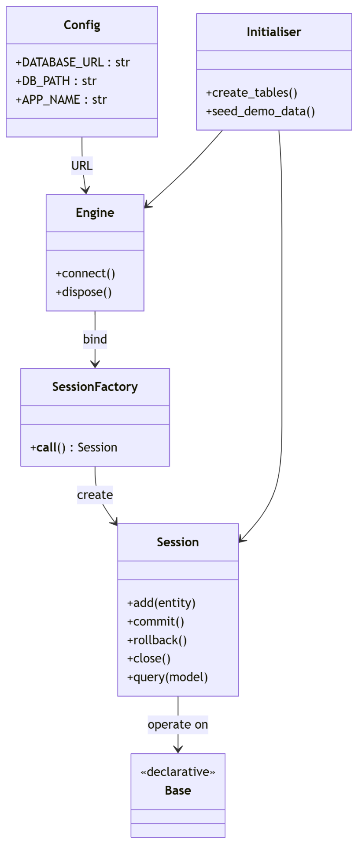
5.4.6 Business Rules
- Database URL is defined in exactly one place — Database/config.py.
- Switching from SQLite to PostgreSQL is a URL swap only; no application code changes.
- Seeding is idempotent: it exits cleanly if any user record already exists.
5.4.7 Error Handling
- Database file corruption → SQLAlchemy OperationalError; caller (repository) surfaces as (False, "Database unavailable")
- Unique constraint violations → caught at service layer, never reaches UI as a raw exception
5.4.8 Traceability
Requirement | Satisfied by
R-Core-01 Persistent storage | Engine + Session
R-Core-02 Referential integrity | Model FK definitions
R-NFR-01 Portable database | Config-driven URL

5.5 Module 2 — Authentication & Authorisation
5.5.1 Purpose
Verify user identity against stored credentials, enforce role selection consistency, and return a serialised user object for the presentation layer.
5.5.2 Responsibilities
- Hash passwords with bcrypt at registration and seeding time
- Verify supplied passwords against stored hashes using constant-time comparison
- Accept login by email or national ID number
- Reject login when the user's stored role does not match the role card selected on the User Type screen
- Clear the login form when the user navigates away or logs out
5.5.3 Public Interface
Class | Method | Signature
Security | hash_password | (plain: str) -> str
Security | verify_password | (plain: str, hashed: str) -> bool
UserRepository | find_by_login | (identifier: str) -> User | None
AuthService | authenticate | (identifier, password, expected_role) -> (bool, dict | None, str | None)
AuthService | register | (id_number, name, email, phone, password, role) -> (bool, str)
AuthController | login | (identifier, password, selected_role) -> (bool, dict | None, str | None)
5.5.4 Dependencies
Module 1 (Database, User entity), bcrypt.

5.5.5 Class Diagram
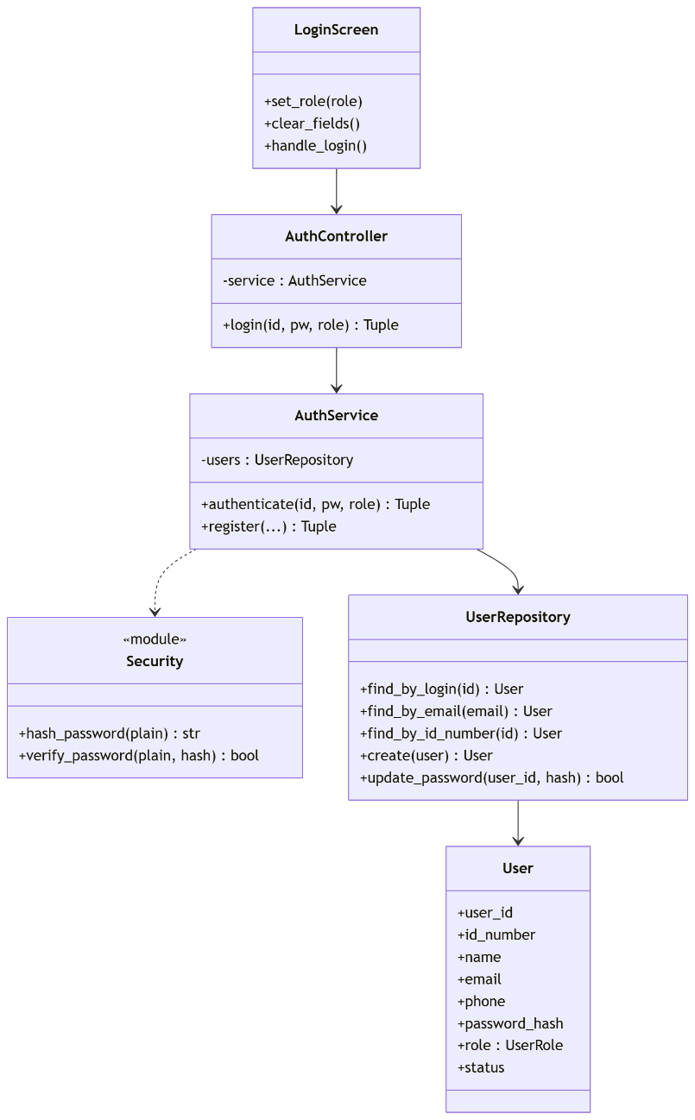
5.5.6 Algorithm — Authenticate
text
Inputs: identifier, password, expected_role
Output: (ok, user_dict, error)

1. If identifier is empty or password is empty:
return (False, None, "Please enter both your ID/email and password.")
2. user ← UserRepository.find_by_login(identifier.strip())
3. If user is None:
return (False, None, "No account found with those details.")
4. If not Security.verify_password(password, user.password_hash):
return (False, None, "Incorrect password.")
5. If expected_role is set and user.role ≠ ROLE_MAP[expected_role]:
return (False, None, "This account is not registered as {expected_role}.")
6. Return (True, user.to_dict(), None)
5.5.7 Business Rules
- Passwords are truncated to 72 bytes before bcrypt hashing (bcrypt's hard limit).
- Failure messages are deliberately specific for this academic system (documented trade-off: real systems should use generic messages to prevent account enumeration).
- Role lookup is case-insensitive on the map key but the map covers exactly the four role strings emitted by the User Type screen.
- On success, only the password field is cleared — the identifier remains so a returning user can log in again quickly.
5.5.8 Traceability
Requirement | Satisfied by
R-Core-10 Secure login | AuthService.authenticate
R-Core-11 Role-based access | Role gate in step 5
R-NFR-03 Password confidentiality | bcrypt hashing

5.6 Module 3 — User Management
5.6.1 Purpose
Allow administrators to create, view, filter, edit and deactivate user accounts across all roles.
5.6.2 Responsibilities
- Provide a filterable table of users
- Enforce unique email and unique national ID number
- Hash passwords at creation and on password reset
- Prevent hard deletion when a user has associated leases or ownerships (offer deactivation instead)
- Restrict all write operations to UserRole.ADMIN
5.6.3 Public Interface
Class | Method | Signature
UserService | list_users | (filters: dict) -> list[dict]
UserService | create_user | (data: dict, session: User) -> (bool, str)
UserService | update_user | (user_id: int, data: dict, session: User) -> (bool, str)
UserService | deactivate_user | (user_id: int, session: User) -> (bool, str)
UserService | reactivate_user | (user_id: int, session: User) -> (bool, str)
5.6.4 Dependencies
Module 1 (User entity), Module 2 (Security.hash_password).

5.6.5 Class Diagram
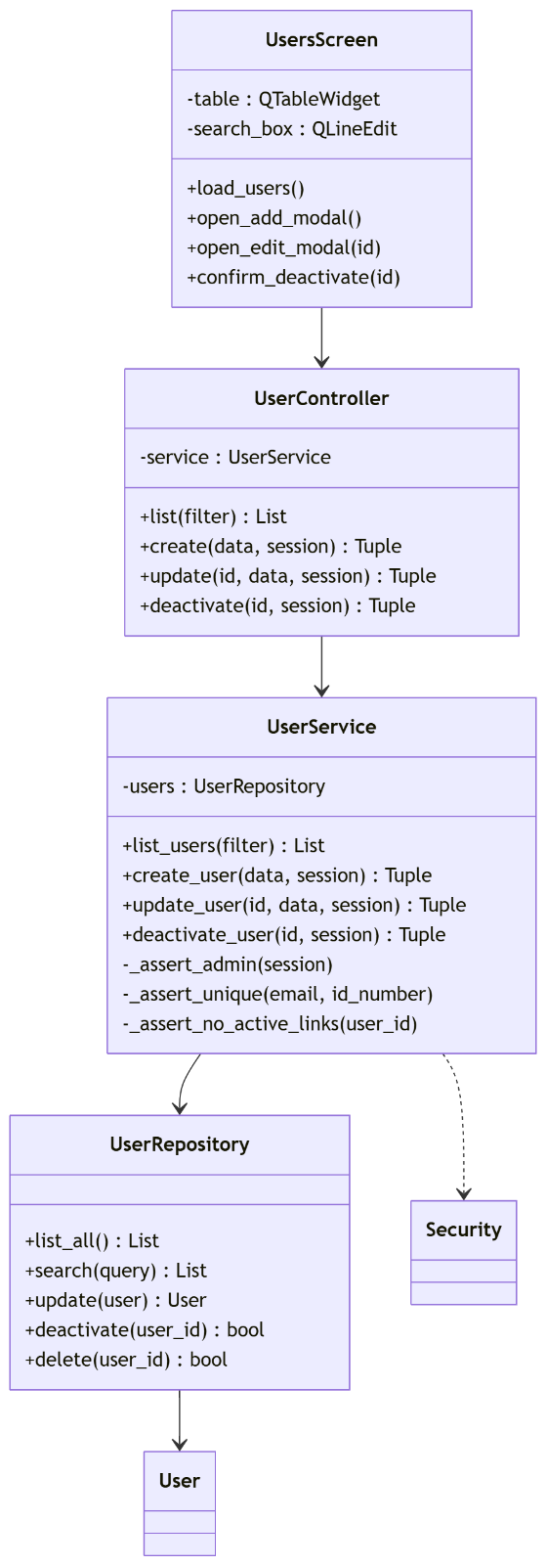
5.6.6 Business Rules
- session.role must equal UserRole.ADMIN for any write operation.
- email and id_number must be unique — enforced by the service before insert.
- Deactivation sets status = "Inactive"; the login module rejects inactive accounts.
- Hard delete is permitted only when the user has no Ownership, Lease, or MaintenanceRequest records.
5.6.7 Traceability
Requirement | Satisfied by
R-Core-20 Admin manages users | UserService write methods
R-Core-21 Account deactivation | deactivate_user
R-NFR-05 Auditability | Retention of user rows on deactivation

5.7 Module 4 — Property Management
5.7.1 Purpose
Manage the lifecycle of property records from registration through occupancy to archival.
5.7.2 Responsibilities
- CRUD operations on Property entities
- Enforce controlled vocabulary for property_type and status
- Recalculate status automatically in response to lease and maintenance events
- Restrict writes to Administrator and Property Manager roles
- Prevent hard deletion of a property with an active lease
5.7.3 Public Interface
Class | Method | Signature
PropertyService | list_properties | (filters: dict) -> list[dict]
PropertyService | create_property | (data: dict, session: User) -> (bool, str)
PropertyService | update_property | (property_id: int, data: dict, session: User) -> (bool, str)
PropertyService | archive_property | (property_id: int, session: User) -> (bool, str)
PropertyService | recalculate_status | (property_id: int) -> str
5.7.4 Dependencies
Module 1; reads from LeaseRepository and MaintenanceRepository for status recalculation.
5.7.5 Class Diagram
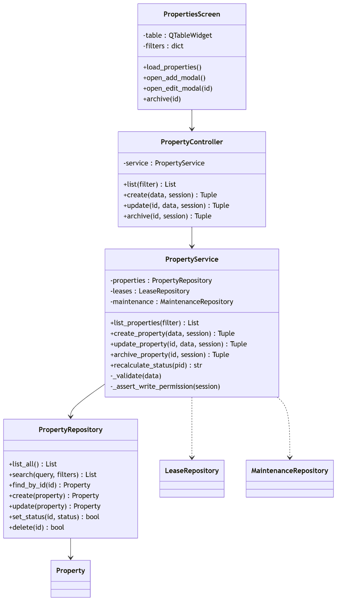
5.7.6 Algorithm — Status Recalculation
text
Input: property_id
Output: new status string

1. If LeaseRepository.has_active_lease(property_id):
new_status ← "Occupied"
2. Else if MaintenanceRepository.has_open_request(property_id):
new_status ← "Under Maintenance"
3. Else:
new_status ← "Available"
4. PropertyRepository.set_status(property_id, new_status)
5. Return new_status
This algorithm is invoked from Module 6 (lease change) and Module 8 (maintenance closure).
5.7.7 Business Rules
- address is required and must be non-empty.
- property_type ∈ {House, Apartment, Commercial, Other}.
- status ∈ {Available, Occupied, Under Maintenance, Archived}.
- Archive is a soft operation — the row remains for historical reporting.
5.7.8 Traceability
Requirement | Satisfied by
R-Core-30 Property CRUD | PropertyService
R-Core-31 Status tracking | recalculate_status

5.8 Module 5 — Ownership Management
5.8.1 Purpose
Model and maintain ownership relationships between users and properties, with support for co-ownership, percentage shares, and historical continuity.
5.8.2 Responsibilities
- Attach one or more owners to a property
- Record each owner's share such that the sum of active shares never exceeds 1.0
- Reject ownership where the target user does not hold the Owner role
- Preserve historical records by closing them with an end date rather than deleting
5.8.3 Public Interface
Class | Method | Signature
OwnershipService | list_for_property | (property_id: int) -> list[dict]
OwnershipService | add_ownership | (data: dict, session: User) -> (bool, str)
OwnershipService | end_ownership | (ownership_id: int, end_date: date, session: User) -> (bool, str)
OwnershipService | active_share_total | (property_id: int) -> float
5.8.4 Dependencies
Modules 1, 3, 4.

5.8.5 Class Diagram
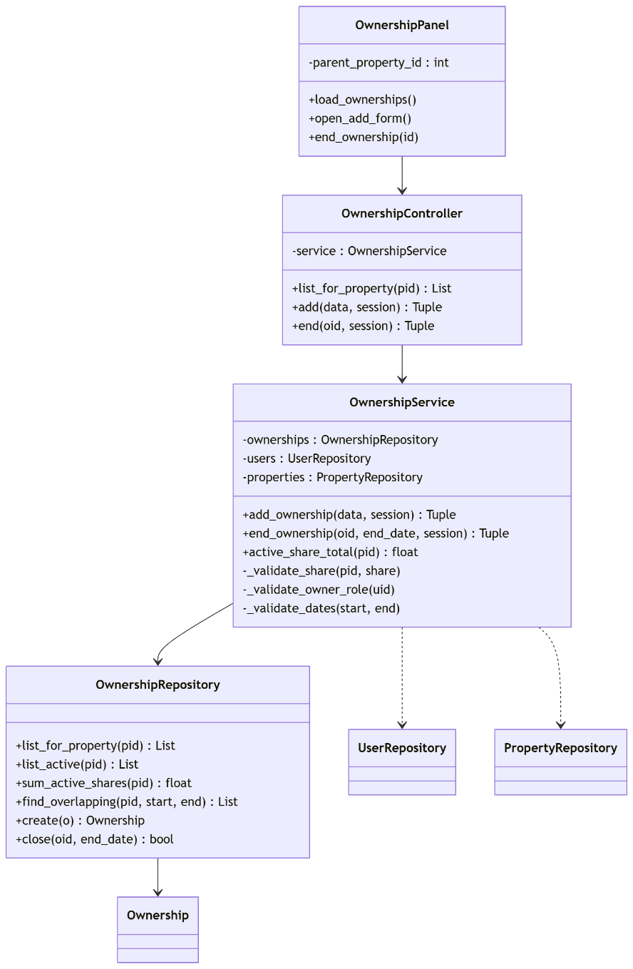
5.8.6 Algorithm — Add Ownership
text
Input: property_id, user_id, share, start_date, end_date
Output: (ok, error)

1. user ← UserRepository.find_by_id(user_id)
2. If user.role ≠ OWNER:
return (False, "Only owners can be assigned ownership")
3. If end_date is set and start_date ≥ end_date:
return (False, "End date must be after start date")
4. current_total ← OwnershipRepository.sum_active_shares(property_id)
5. If current_total + share > 1.0:
return (False, "Total ownership shares would exceed 100%")
6. OwnershipRepository.create(property_id, user_id, share, start, end)
7. Return (True, None)
5.8.7 Business Rules
- Active shares for a property at any instant ≤ 1.0.
- Only users with UserRole.OWNER may be assigned ownership.
- Ending ownership is a soft operation — end_date is set; the row is preserved.
5.8.8 Traceability
Requirement | Satisfied by
R-Core-40 Ownership recording | OwnershipService.add_ownership
R-Core-41 Co-ownership support | Share field + sum constraint

5.9 Module 6 — Lease Management
5.9.1 Purpose
Create, manage and terminate lease agreements between property owners and tenants, and detect leases approaching expiry.
5.9.2 Responsibilities
- Create leases linking a property to a tenant with a rent amount and date range
- Enforce the constraint that a property may have only one active lease at a time
- Generate the first payment record on lease creation (delegates to Module 7)
- Trigger property status recalculation on lease creation or termination
- Provide an expiry-detection query for the scheduler
5.9.3 Public Interface
Class | Method | Signature
LeaseService | list_leases | (filters: dict) -> list[dict]
LeaseService | create_lease | (data: dict, session: User) -> (bool, str)
LeaseService | terminate_lease | (lease_id: int, session: User) -> (bool, str)
LeaseService | check_expiring | (threshold_days: int = 30) -> list[dict]
5.9.4 Dependencies
Modules 1, 4 (property), 3 (tenant existence), 7 (initial payment), 9 (notifications).
5.9.5 Class Diagram
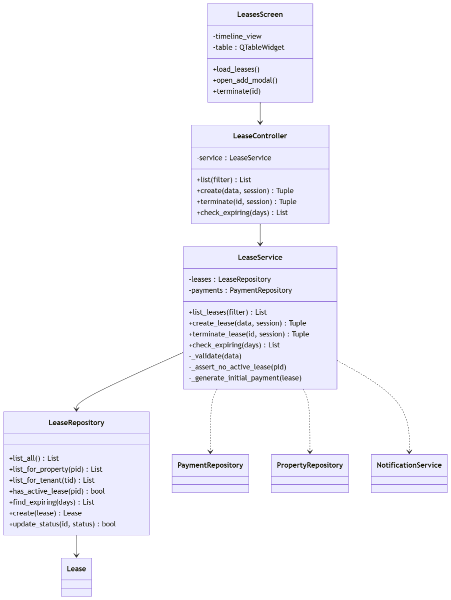

5.9.6 Algorithm — Create Lease
text
Input: property_id, tenant_id, start_date, end_date, rent_amount
Output: (ok, error)

1. If rent_amount ≤ 0:
return (False, "Rent must be greater than zero")
2. If start_date ≥ end_date:
return (False, "Start date must be before end date")
3. If LeaseRepository.has_active_lease(property_id):
return (False, "Property already has an active lease")
4. lease ← LeaseRepository.create(...)
5. PaymentRepository.create(lease_id=lease.lease_id,
amount=lease.rent_amount,
due_date=start_date,
status="Pending")
6. PropertyService.recalculate_status(property_id)
7. Return (True, None)
5.9.7 Business Rules
- A property may hold at most one status = "Active" lease at any time.
- Terminating a lease sets status to "Terminated" and recalculates the property status.
- check_expiring is purely a query — the notifications are emitted by the scheduler task in Module 10, not by the service.
5.9.8 Traceability
Requirement | Satisfied by
R-Core-50 Lease CRUD | LeaseService
R-Core-51 Lease expiry alert | check_expiring + Module 10 task
R-Core-52 Payment on lease creation | _generate_initial_payment

5.10 Module 7 — Payment Management
5.10.1 Purpose
Track rent payments against leases, mark them paid, and automatically identify overdue payments.
5.10.2 Responsibilities
- Persist payment records tied to a lease
- Mark a payment as paid with a paid_date
- Detect overdue payments (due date in the past and status not Paid) and transition them to Overdue
- Emit overdue notifications via Module 9
5.10.3 Public Interface
Class | Method | Signature
PaymentService | list_payments | (filters: dict) -> list[dict]
PaymentService | create_payment | (data: dict, session: User) -> (bool, str)
PaymentService | mark_paid | (payment_id: int, paid_date: date, session: User) -> (bool, str)
PaymentService | check_overdue | () -> int
5.10.4 Dependencies
Modules 1, 6 (Lease), 9 (Notification).

5.10.5 Class Diagram
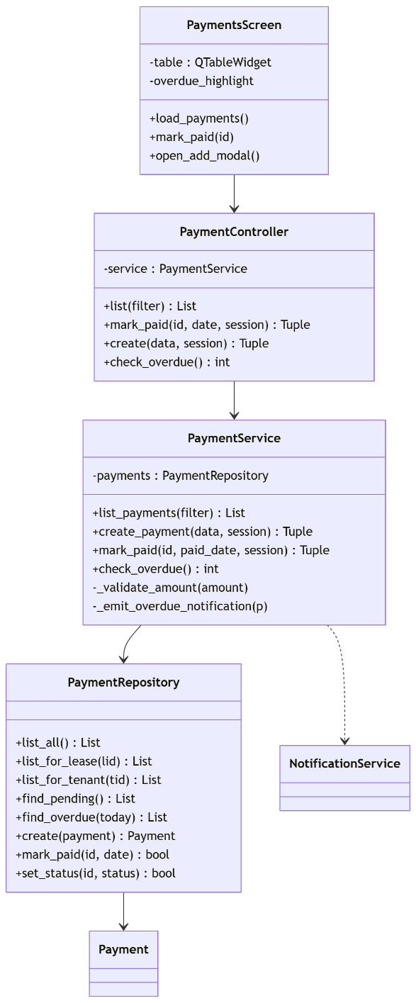
5.10.6 Algorithm — Overdue Detection
text
Output: count of newly-overdue payments

1. today ← date.today()
2. newly_overdue ← 0
3. For each payment in PaymentRepository.find_pending():
If payment.due_date < today:
PaymentRepository.set_status(payment.payment_id, "Overdue")
NotificationService.emit(
user_id = payment.lease.tenant_id,
type = "payment_overdue",
title = "Payment overdue",
message = "Payment #{id} was due on {due_date}"
)
newly_overdue += 1
4. Return newly_overdue
5.10.7 Business Rules
- Amount must be strictly positive.
- Once marked paid, a payment cannot be reverted to Pending through the UI.
- Overdue detection is idempotent — running it repeatedly produces no duplicate notifications because the status transition only fires once.
5.10.8 Traceability
Requirement | Satisfied by
R-Core-60 Payment recording | PaymentService.create_payment
R-Core-61 Overdue detection | check_overdue

5.11 Module 8 — Maintenance Management
5.11.1 Purpose
Enable tenants to submit maintenance requests for properties they lease, and enable managers to track, prioritise and close those requests.
5.11.2 Responsibilities
- Validate that a tenant submitting a request has an active lease on the referenced property
- Enforce the state machine Open → In Progress → Resolved → Closed, with permitted rework transitions
- Notify the submitter and the property owner on status change
- Trigger property status recalculation on closure
5.11.3 Public Interface
Class | Method | Signature
MaintenanceService | list_requests | (filters: dict) -> list[dict]
MaintenanceService | submit_request | (data: dict, session: User) -> (bool, str)
MaintenanceService | update_status | (request_id: int, new_status: str, session: User) -> (bool, str)
5.11.4 Dependencies
Modules 1, 3, 4, 6, 9.

5.11.5 Class Diagram
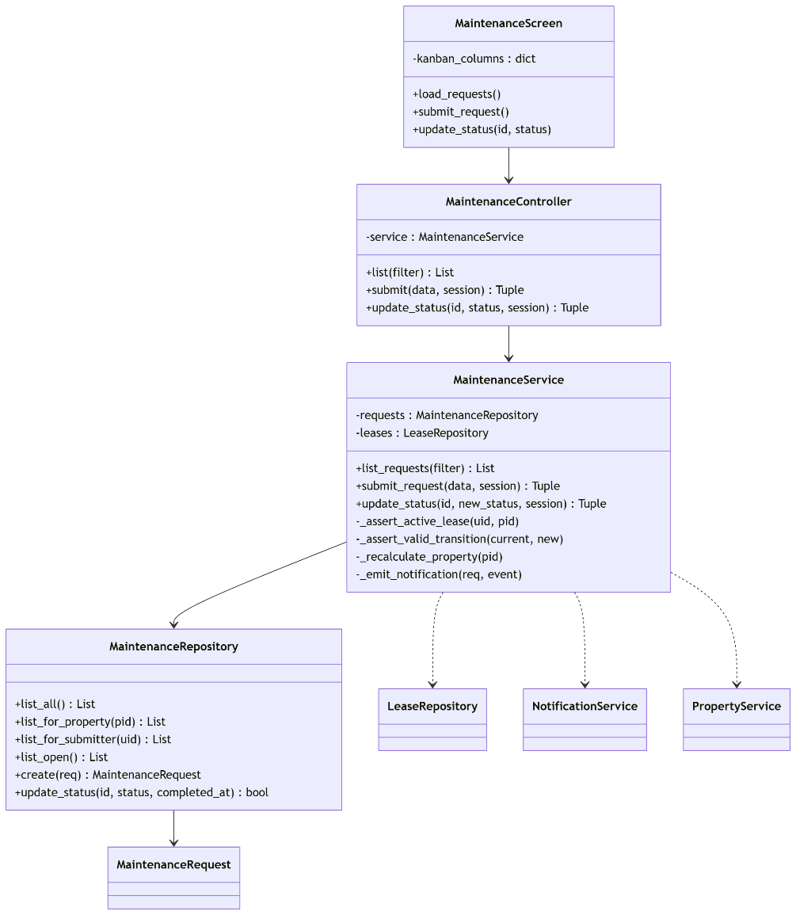
5.11.6 Algorithm — Status Transition
text
Allowed transitions:
Open → [In Progress]
In Progress → [Resolved]
Resolved → [Closed, In Progress]
Closed → []

Input: request_id, new_status
Output: (ok, error)

1. req ← MaintenanceRepository.find_by_id(request_id)
2. If new_status ∉ ALLOWED[req.status]:
return (False, "Invalid transition from {req.status} to {new_status}")
3. If new_status = "Closed":
MaintenanceRepository.update_status(id, "Closed", completed_at=now())
PropertyService.recalculate_status(req.property_id)
4. Else:
MaintenanceRepository.update_status(id, new_status, completed_at=None)
5. NotificationService.emit(to=req.submitted_by, type="maintenance_update", ...)
6. Return (True, None)
5.11.7 Business Rules
- Description must be non-empty.
- Priority ∈ {Low, Medium, High, Urgent}.
- Only Manager or Administrator may change priority or close a request.
- On close, completed_at is set.
5.11.8 Traceability
Requirement | Satisfied by
R-Core-70 Submit maintenance | submit_request
R-Core-71 Status transitions | update_status

5.12 Module 9 — Notification & Preference System
5.12.1 Purpose
Centralise all system events into user-facing notifications, and provide per-user control over delivery channels.
5.12.2 Responsibilities
- Persist Notification records produced by any other module
- Track read/unread state via a nullable read_at timestamp
- Expose unread count and unread-first list
- Store per-user, per-event-type preferences
- Route notifications through the correct channels (dashboard, email) at emit time
- Queue outbound emails when email delivery is enabled
5.12.3 Public Interface
Class | Method | Signature
NotificationService | emit | (user_id, type, title, message, priority="Normal") -> Notification
NotificationService | list_for_user | (user_id: int) -> list[dict]
NotificationService | mark_read | (notification_id: int) -> bool
NotificationService | unread_count | (user_id: int) -> int
PreferenceService | get | (user_id, event_type) -> NotificationPreference
PreferenceService | set | (user_id, event_type, prefs: dict) -> bool
5.12.4 Dependencies
Module 1 (entities), Module 10 (EmailService.queue).

5.12.5 Class Diagram
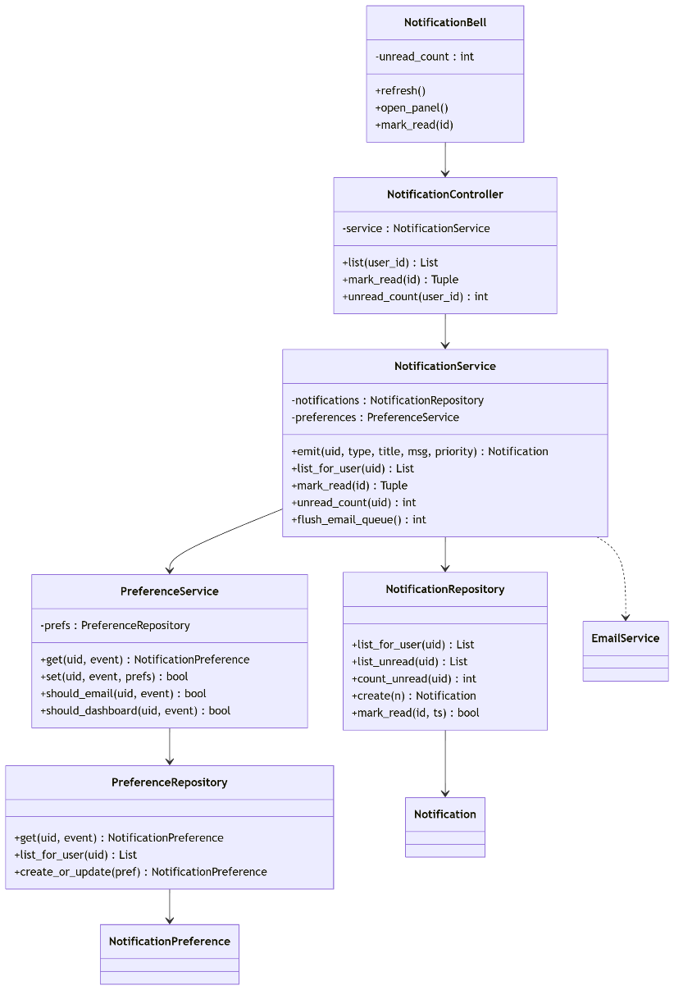
5.12.6 Algorithm — Emit
text
Input: user_id, type, title, message, priority
Output: persisted Notification

1. pref ← PreferenceService.get(user_id, type)
(falls back to defaults if no explicit preference row exists)
2. n ← Notification(user_id, type, title, message, priority,
created_at=now(), read_at=None)
3. NotificationRepository.create(n)
4. If pref.email_enabled:
EmailService.queue(n)
5. If pref.dashboard_enabled:
(dashboard reads unread_count on next refresh — no push needed)
6. Return n
5.12.7 Business Rules
- A notification row is always persisted, regardless of channel preference. Preference controls delivery, not persistence.
- read_at IS NULL identifies unread notifications; this single nullable column is sufficient and index-friendly.
- Email delivery is a queued operation — failures in the email subsystem never block a user action.
5.12.8 Traceability
Requirement | Satisfied by
R-Core-80 In-app notifications | NotificationService.emit
R-Core-81 User preferences | PreferenceService
R-NFR-06 Non-blocking email | Queue design

5.13 Module 10 — Dashboard, Reporting & Email Dispatch
5.13.1 Purpose
Present role-aware aggregated data on the dashboard, produce downloadable reports, and run the daily scheduled reminders that other modules depend on.
5.13.2 Responsibilities
- Aggregate statistics for the logged-in user's role
- Render charts and activity feed in the dashboard
- Generate PDF reports on demand
- Run the daily reminder task: lease expiry check, payment overdue check, email flush
- Dispatch queued emails via SMTP
5.13.3 Public Interface
Class | Method | Signature
DashboardService | aggregate_for | (user: dict) -> dict
ReportService | generate_property_report | (filter: dict) -> bytes
ReportService | generate_payment_report | (filter: dict) -> bytes
EmailService | send | (to, subject, body) -> bool
EmailService | queue | (notification) -> None
EmailService | flush | () -> int
Scheduler | start / stop | () -> None
ReminderTask | run | () -> None
5.13.4 Dependencies
All other modules (read side only).
5.13.5 Class Diagram
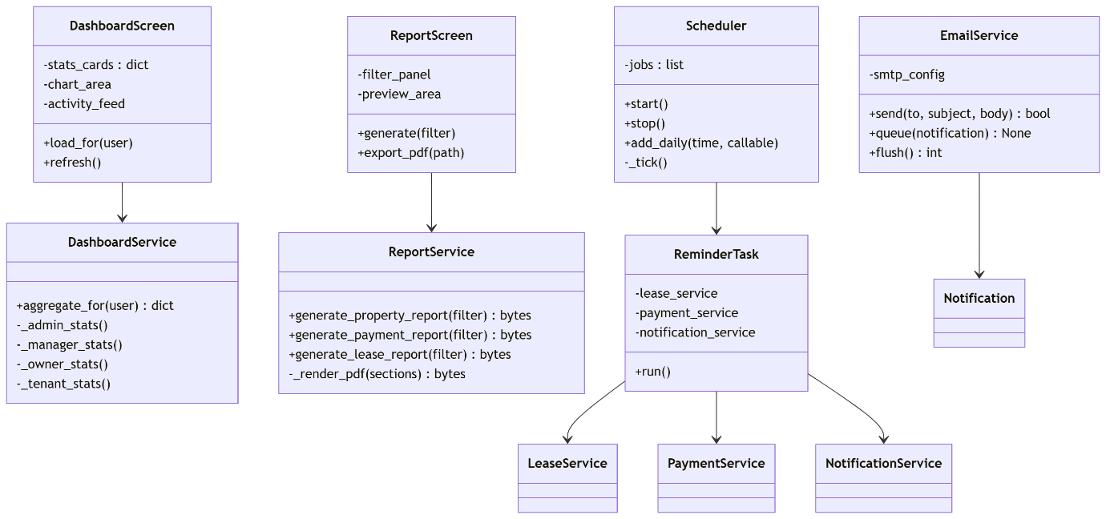
5.13.6 Algorithm — Role-Aware Aggregation
text
Input: user dict (contains user_id and role)
Output: stats dict

switch user.role:

case ADMIN:
stats = {
"users": count(User),
"properties": count(Property),
"active_leases": count(Lease where status="Active"),
"overdue_payments": count(Payment where status="Overdue")
}

case MANAGER:
stats = {
"properties_managed": count(Property),
"active_leases": count(Lease where status="Active"),
"open_maintenance": count(Maintenance where status IN ["Open","In Progress"]),
"upcoming_expiries": count(Lease where end_date ≤ today+30)
}

case OWNER:
owned ← [o.property_id for o in Ownership where user_id=user.id and end_date is null]
stats = {
"owned_properties": len(owned),
"active_leases": count(Lease where property_id ∈ owned and status="Active"),
"payments_due_month": sum(Payment.amount where lease.property_id ∈ owned
and status="Pending"
and month(due_date)=current_month)
}

case TENANT:
stats = {
"my_lease": Lease where tenant_id=user.id and status="Active",
"next_payment": earliest Payment where lease.tenant_id=user.id and status="Pending",
"my_open_issues": count(Maintenance where submitted_by=user.id and status != "Closed")
}

return stats
5.13.7 Algorithm — Scheduler Daily Job
text
Every day at 08:00 local:

1. LeaseService.check_expiring(30)
2. PaymentService.check_overdue()
3. EmailService.flush()

Email flush dequeues notifications from the outbound table and sends
them one at a time; failures are logged and retried on the next tick.
5.13.8 Business Rules
- Dashboard content is strictly role-scoped — no cross-role data leakage.
- Reports are written to Documentation/reports/ with a timestamped filename.
- Scheduler runs in a background thread; UI remains responsive.
- Email is optional — if SMTP credentials are absent, the flush step is skipped, and the system continues working with in-app notifications only.
5.13.9 Traceability
Requirement | Satisfied by
R-Core-90 Role-specific dashboard | aggregate_for
R-Core-91 Reports | ReportService
R-Core-92 Email reminders | EmailService + Scheduler

5.14 Cross-Module Interactions
The following three interactions summarise how modules cooperate at runtime. Each has been captured as a sequence diagram in Chapter 3; the Phase 3 description below names the modules involved.
Interaction | Modules involved | Trigger
Login | 2, 1 | User action
Add Property | 4, 1 | Manager action
Reminder Dispatch | 10, 6, 7, 9 | Scheduled task
Maintenance Lifecycle | 8, 6, 4, 9 | Tenant and manager actions

5.15 Module Dependency Graph
Ordered by dependency depth — a valid top-down implementation order for Phase 4:
Level | Modules
0 | 1 — Database Foundation
1 | 2 — Authentication
2 | 3 — User Management, 4 — Property Management
3 | 5 — Ownership, 6 — Lease, 8 — Maintenance
4 | 7 — Payment
5 | 9 — Notification System
6 | 10 — Dashboard, Reporting & Email

5.16 Requirements Traceability Matrix
Requirement ID | Description | Module(s) satisfying
R-Core-01 | Persistent storage | 1
R-Core-02 | Referential integrity | 1
R-Core-10 | Secure login | 2
R-Core-11 | Role-based access | 2, 3, 4, 6, 7, 8
R-Core-20 | Admin manages users | 3
R-Core-21 | Account deactivation | 3
R-Core-30 | Property CRUD | 4
R-Core-31 | Property status tracking | 4, 6, 8
R-Core-40 | Ownership recording | 5
R-Core-41 | Co-ownership support | 5
R-Core-50 | Lease CRUD | 6
R-Core-51 | Lease expiry alert | 6, 9, 10
R-Core-52 | Auto-generate initial payment | 6, 7
R-Core-60 | Payment recording | 7
R-Core-61 | Overdue detection | 7, 9, 10
R-Core-70 | Submit maintenance | 8
R-Core-71 | Status transitions | 8
R-Core-80 | In-app notifications | 9
R-Core-81 | User notification preferences | 9
R-Core-90 | Role-specific dashboard | 10
R-Core-91 | Reports | 10
R-Core-92 | Email reminders | 10
R-NFR-01 | Portable database | 1
R-NFR-02 | Layered architecture | all
R-NFR-03 | Password confidentiality | 2
R-NFR-05 | Auditability | 3
R-NFR-06 | Non-blocking email | 10

Note: as this is a draft, contents and functions of final project subject to change after review and workload estimation amongst lecturer and group members.

